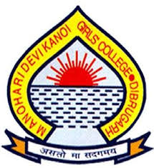
Manohari Devi Kanoi Girls’ College,
K.C. Gogoi Path, Khalihamari, Dibrugarh-1

A Report on
Observation of National Technology Day
11TH MAY, 2023

Organized by
Department of Computer Science,
Manohari Devi Kanoi Girls’ College, Dibrugarh
In Collaboration with
Internal Quality Assurance Cell
Manohari Devi Kanoi Girls’ College, Dibrugarh

Report By
Ms. Rimpi Sarma,
Assistant Professor and HOD,
Department of Computer Science,
M.D.K.G.College, Dibrugarh
An Invited talk Programme on “5G and Cognitive radio network” was held at MDKG College on 11th May,2023 on the occasion of National Technology Day Organised by Department of Computer Science in collaboration with IQAC, MDKG College. The Programme was inaugurated by Dr. Nibedita Phukan , Principal of the college. In her inaugural Speech , Dr. Phukan explained how national technology day was evolved as it is realised in the national scenario. Ms Utpala Borgohain , assistant Professor of Centre for Computer Science and Application , Dibrugarh University acted as a resource person of the talk programme .In her Speech Ms Borgohain described about the evolutionary stage of 5Gand cognitive radio network from its very root of 1G in an algorithmic manner. She illustrated the magnification data of 5G spectrums all over the world focusing on developed and developing countries of the world with pros and cons. The resource person cleared the doubts raised by the participants of the programme. At the end of this program, the completion certificates of add-on courses were distributed among the students. The programme ended with vote of thanks from the organiser.
Here are the few snapshot of the invited talk
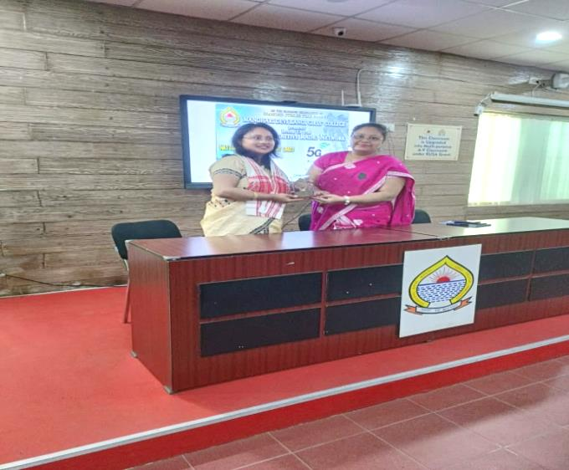
Pic 1: Felicitation of resource Person by Principal Madam

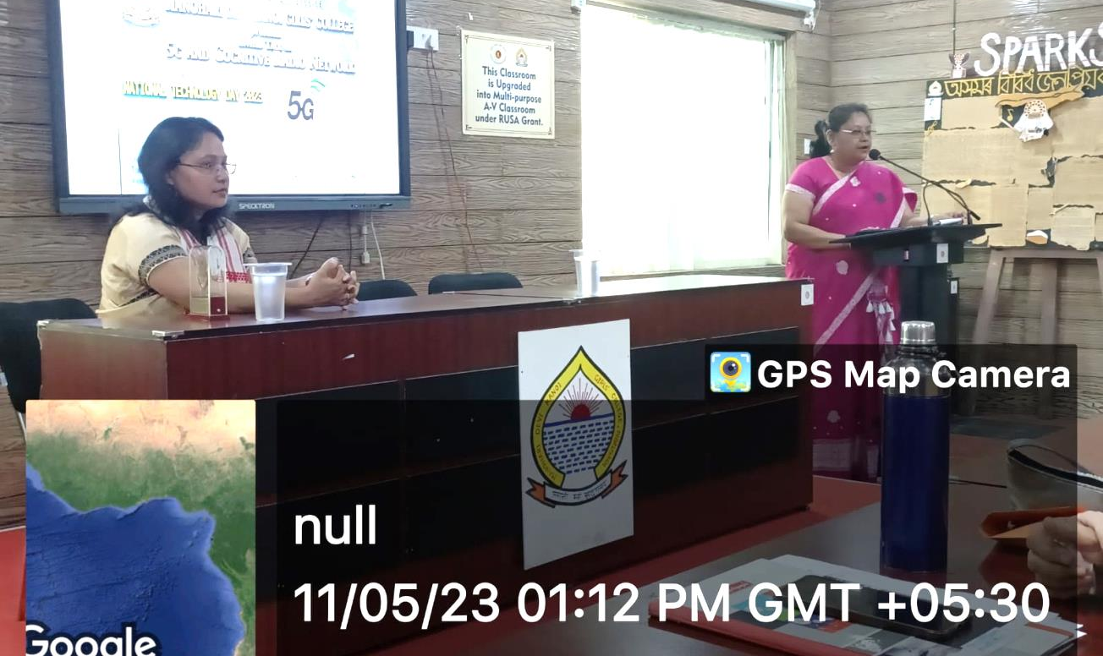
Pic 2: Inaugural speech by Principal Madam

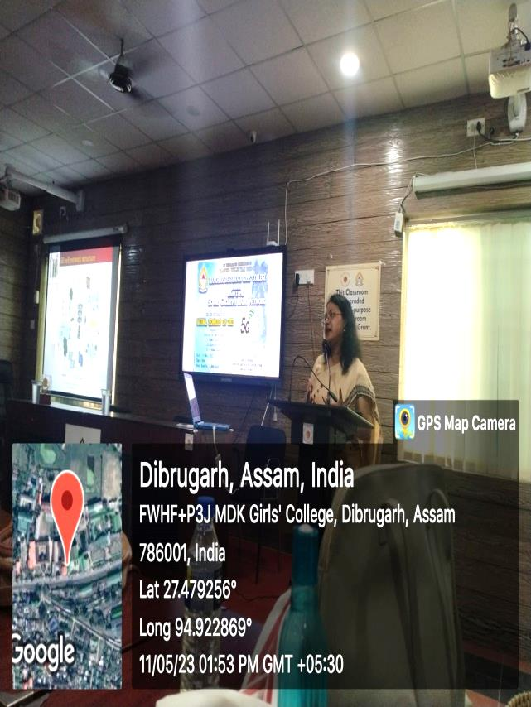
Pic 3: Invited Talk Delivered by Resource Person

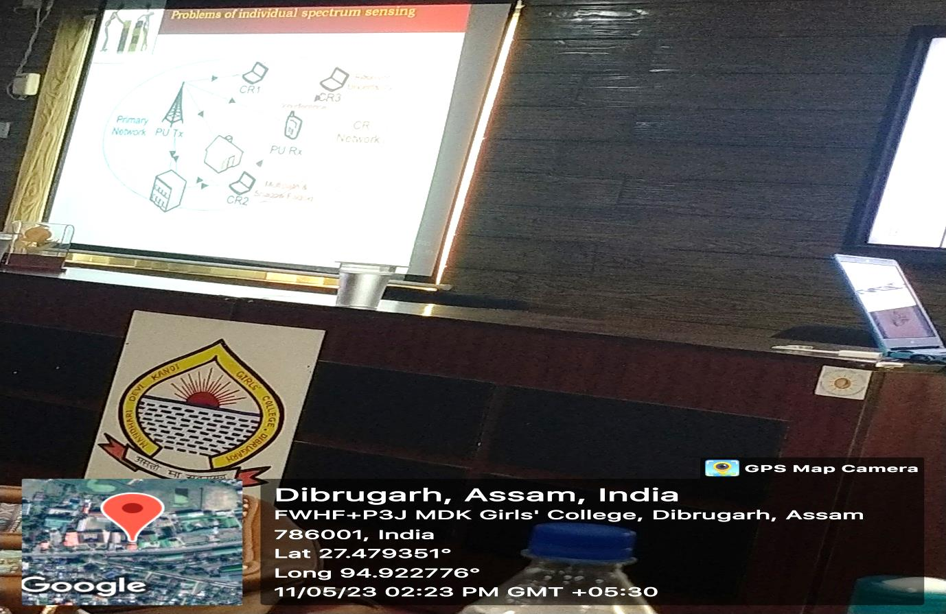
Pic4&5 : Content slide

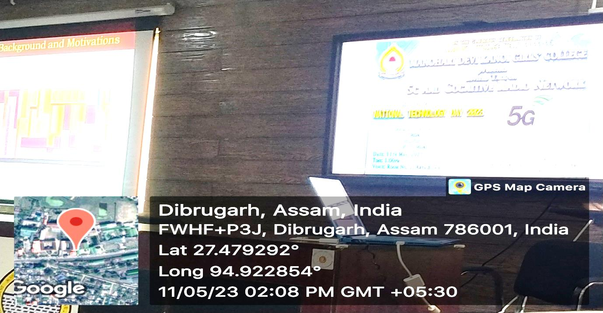

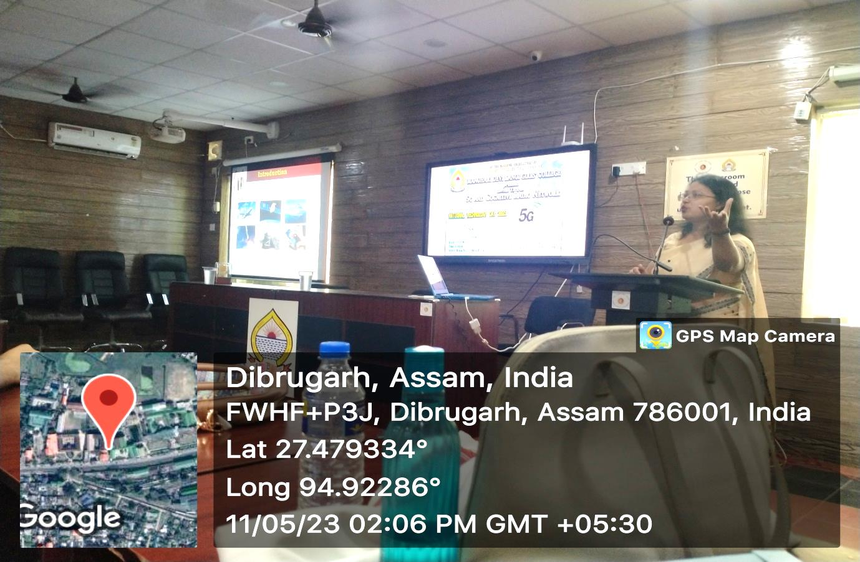

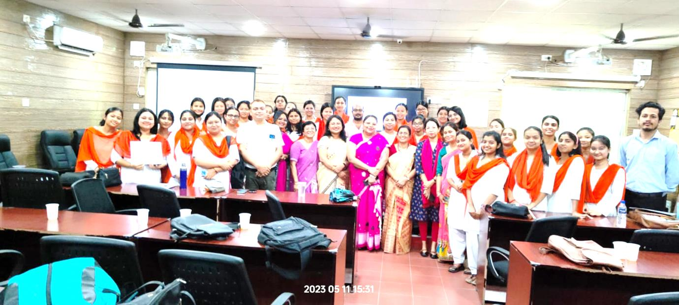

group photo

Certificate distribution of add-on courses
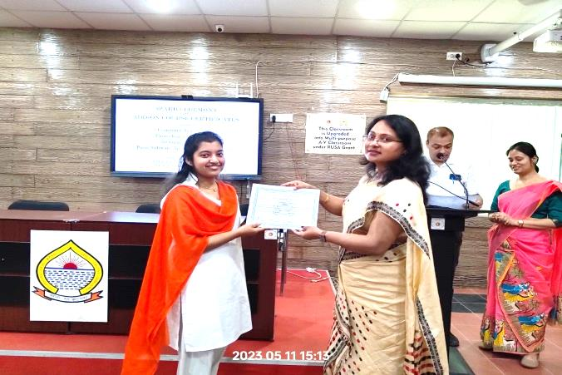 | 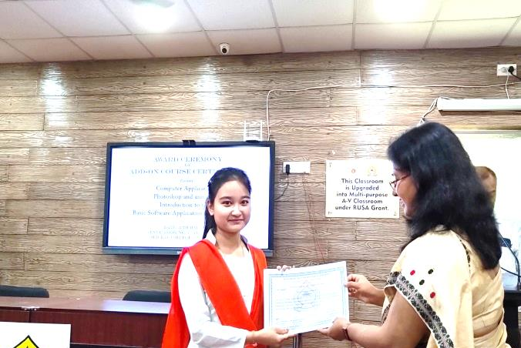
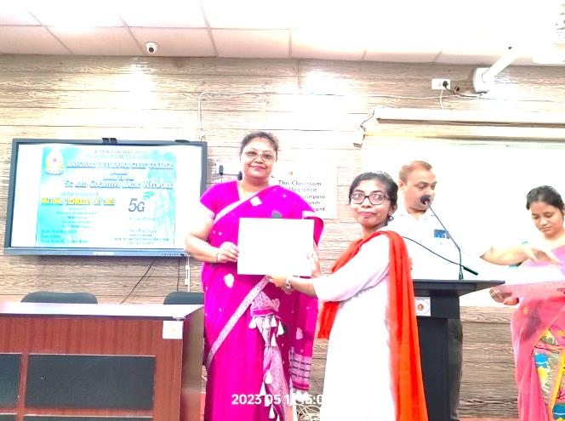 | 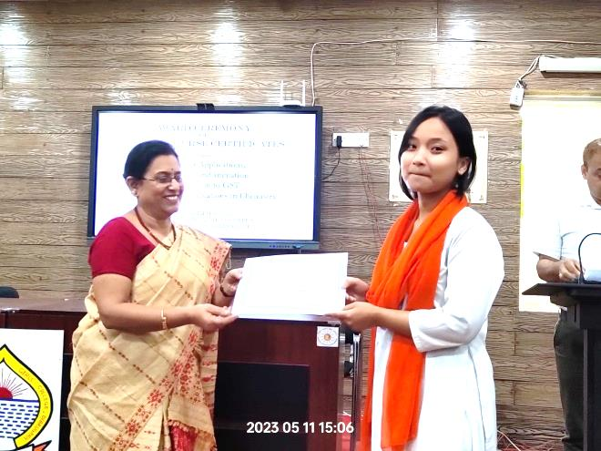
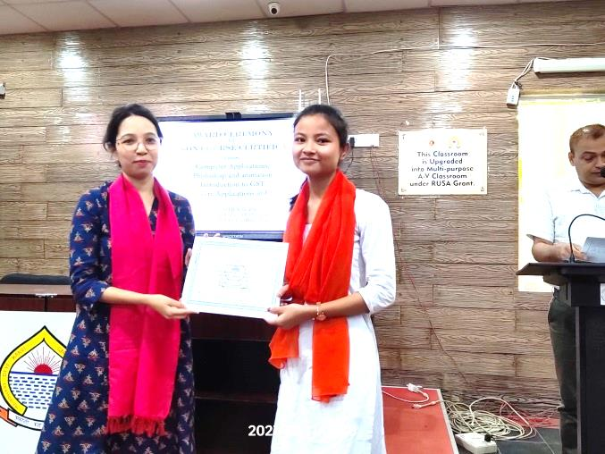 | 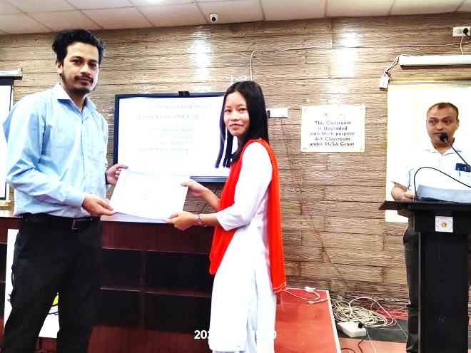

Attendance Records
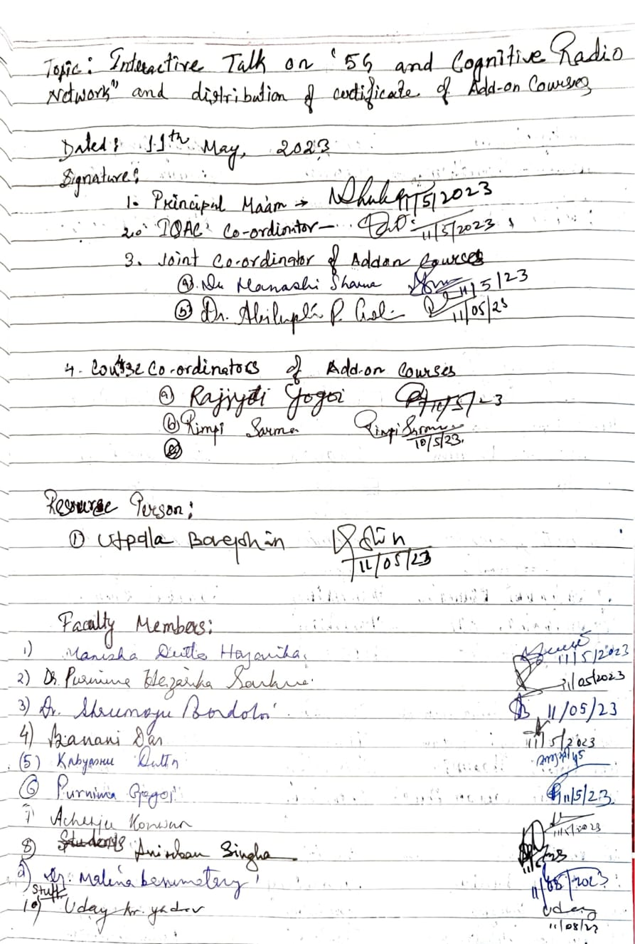

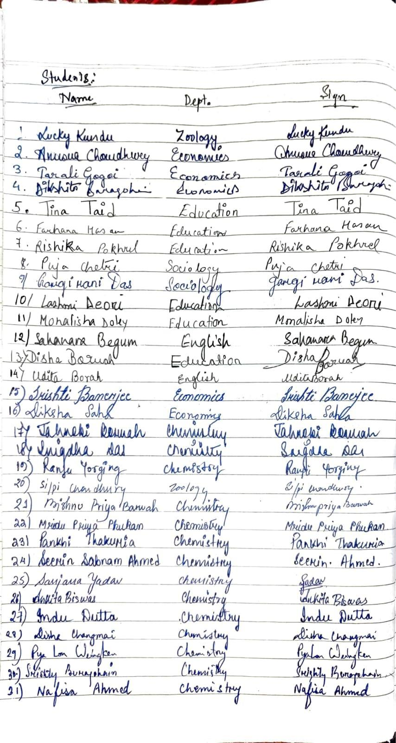

Feedback of Resource person

